|  |
| --- |
| ECSE 490 – Digital Signal Processing Lab |
| Experiment 1 |
| Implementing Audio Effects in MATLAB and Simulink |

|  |
| --- |
| Group 1 -Isabel Helleur (2603507130) and Loren Lugosch(260404057)  February 6, 2013 |

## 1.2 Reverberation

Reverberations of sounds can be expressed in terms of a delay $(x\left[n-D_{i}\right])$ and attenuation $(α_{i})$ of the initial signal.

$$y\left[n\right]= \sum_{i}{α_{i}}x\left[n-D_{i}\right]= h\left[n\right]*x[n]$$

## 1.2.1 FIR Comb Filter

A finite impulse response filter can be described by the impulse response:

$$h[n] = δ[n] + Gδ[n-M]$$

Where M is a delay of a certain number of samples and G is some amplitude scaling factor where G < |1|.

## 1.2.2 IIR Reverberator

The IIR reverberator can be described with a transfer function:

$$H\left(z\right)=\frac{1}{1-Gz^{-M}}$$

Its impulse response can then be calculated using the inverse z-transform:

$$h\left[n\right]=G^{\frac{n}{M}}u\left[n\right]$$

This can simulate the reverberations of a room because the impulse response generates attenuated echoes of the original impulse, much like sound waves reflecting off of the walls of a room.

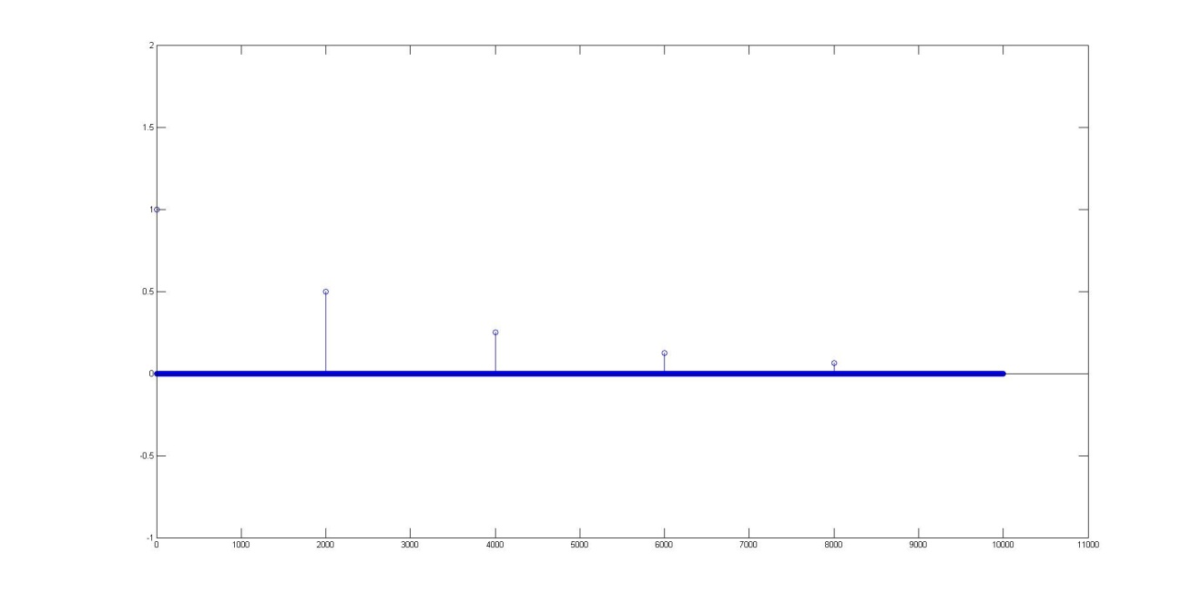

Figure - IIR Reverberation

In order for the reverberator to be stable, the Region of Convergence for the transfer function must include the unit circle and therefore |G|<1.

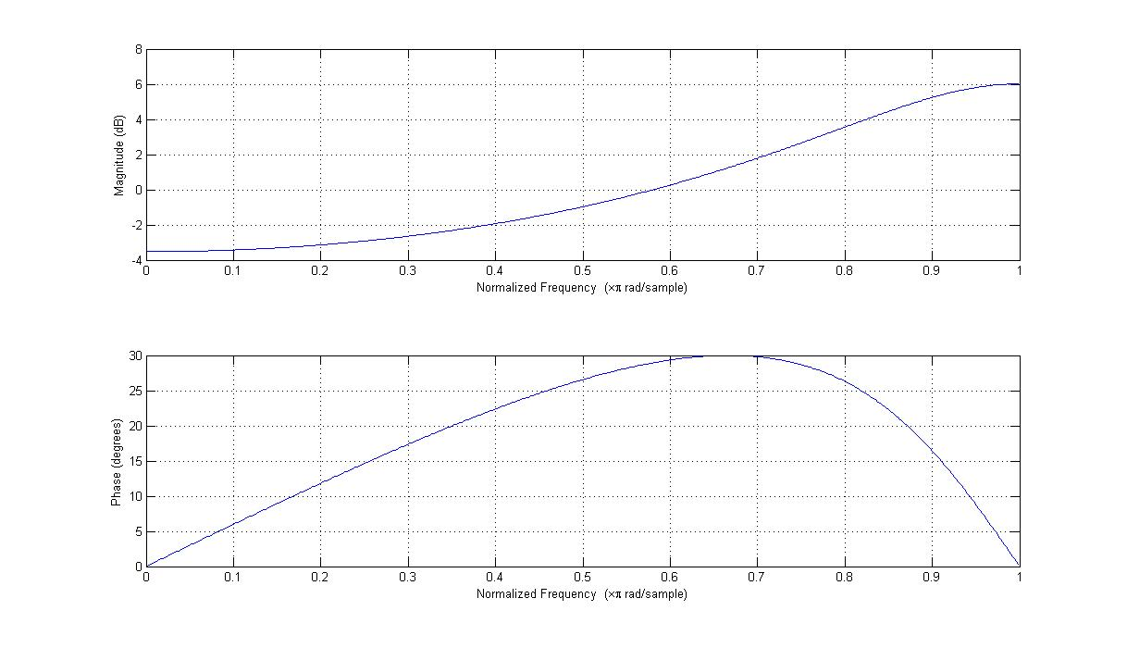

Figure 2- Frequency response of the IIR Reverberator with M=1 and G=1/2

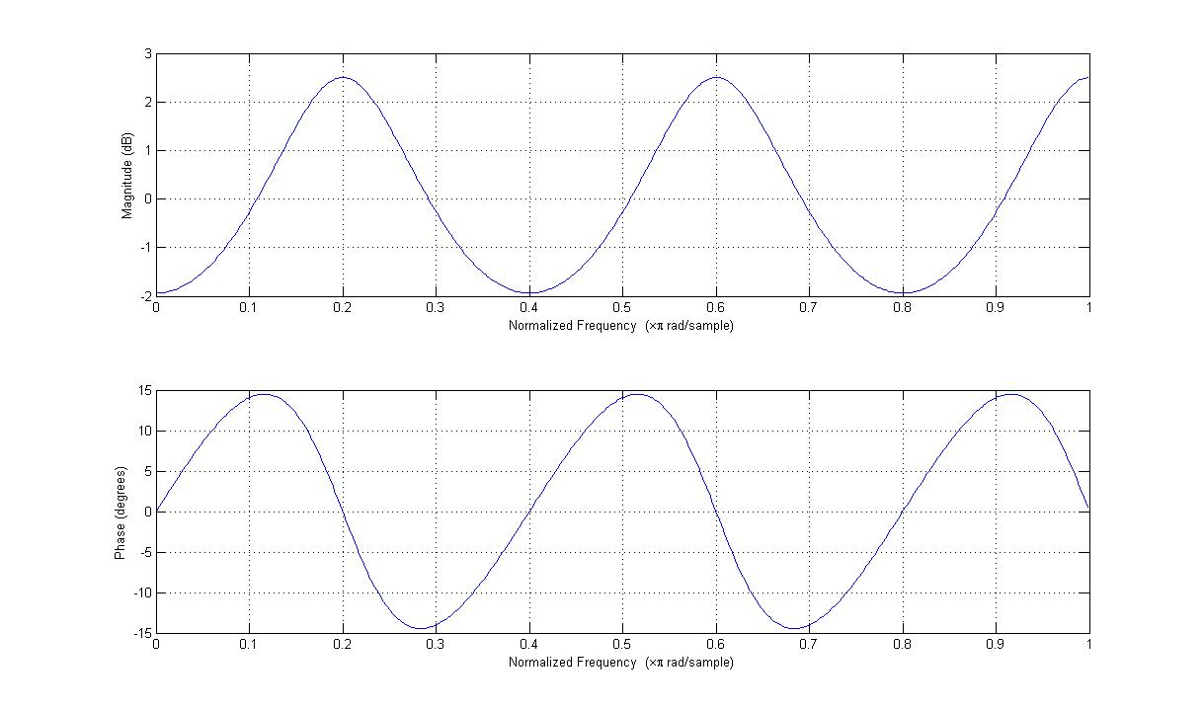

Figure - Frequency response of the IIR Reverberator with M=5 and G=1/4

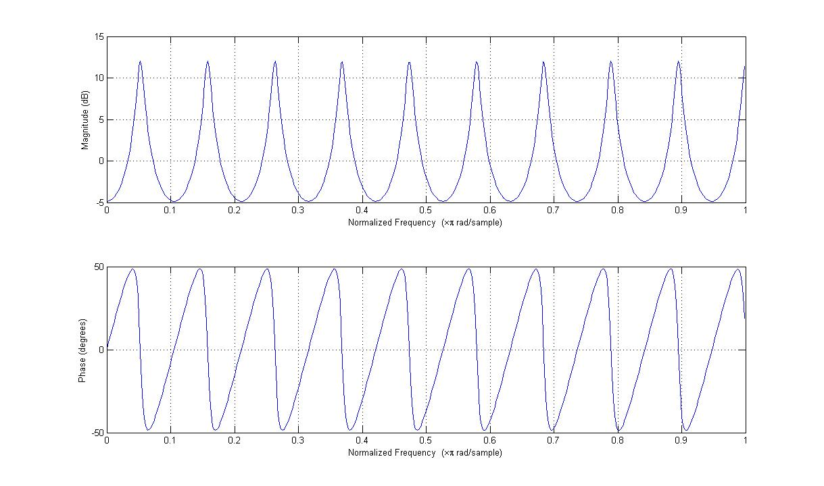

Figure - Frequency response of the IIR Reverberator with M=19 and G=3/4

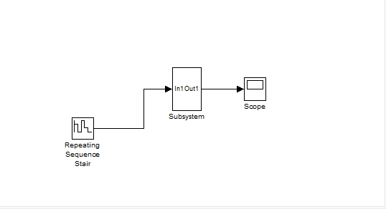

Figure - IIR Reverberator in Simulink

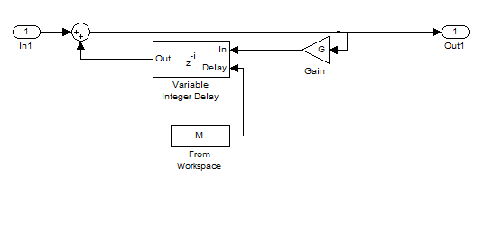

Figure - IIR Reverberator Subsystem in Simulink

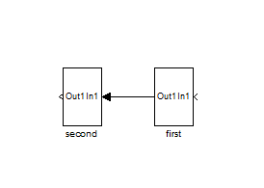

Figure - Cascade of IIR Reverberators

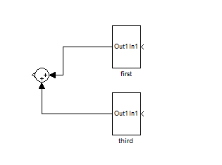

Figure - Different IIR Reverberator Blocks In Parallel

## 1.2.3 Allpass reverberator model

An allpass filter can be described with a transfer function of the form

$$A\left(z\right)=\frac{a+bz^{-1}}{b+az^{-1}}$$

We calculated the frequency response for this filter in Matlab for both a = 10 and b = 10.

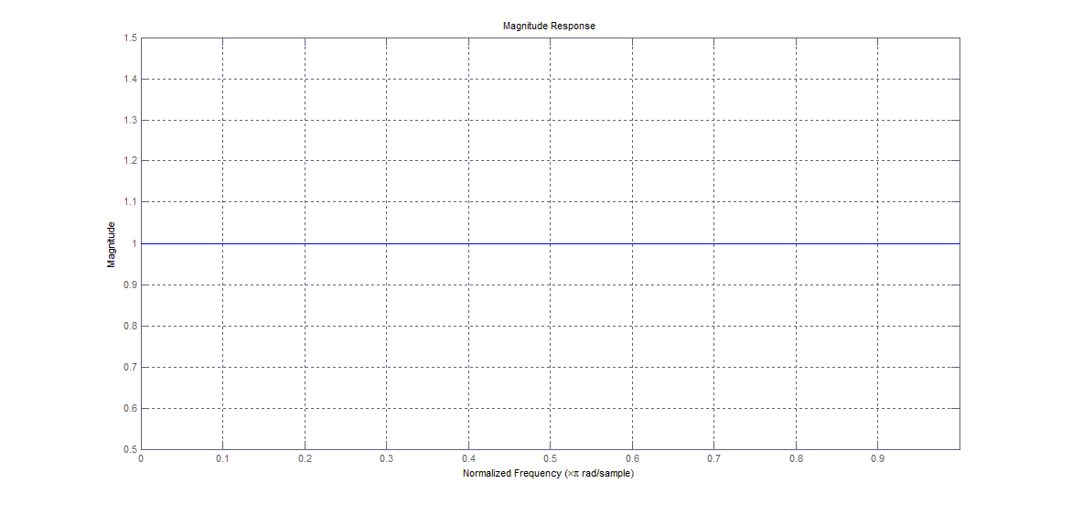

Figure 9 - Frequency response of an allpass filter

Using these same values for a and b, we also plotted its impulse response.

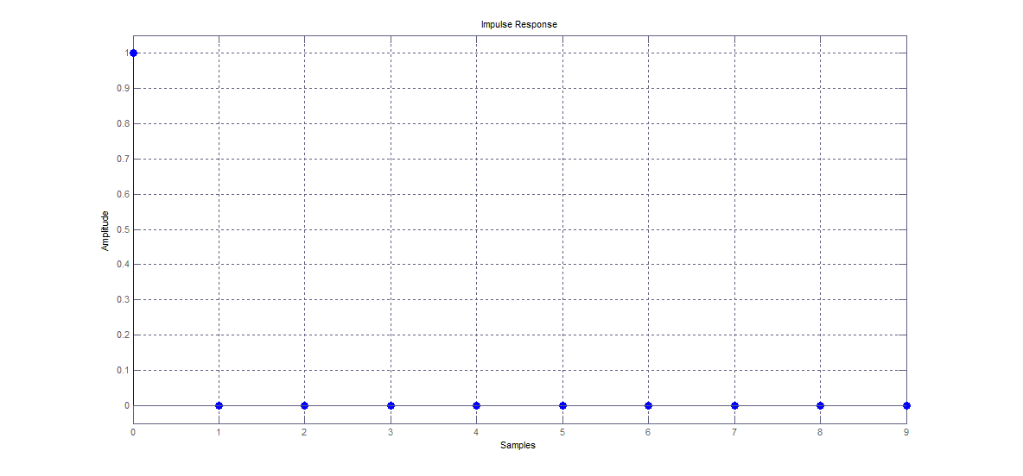

Figure 10 - Impulse response of an allpass filter

An allpass filter can approximate a reverberator because different frequency components have different phase delays, so parts of the signal at one time will overlap with other parts of the signal at another time, giving the impression of an echo.

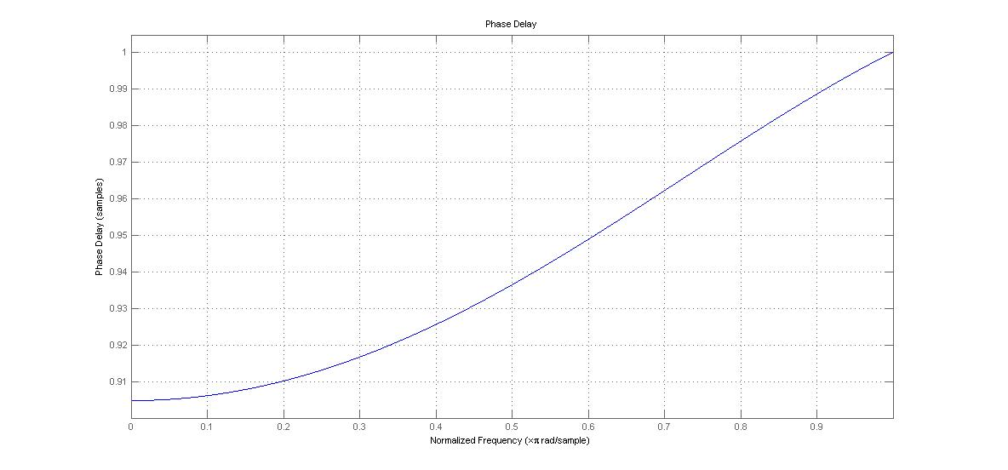

Figure - Phase delay of an allpass with the same parameters

By first finding the pole(s) of the transfer function, which is $z=\frac{a}{b}$ it can be seen that stability can be assured by the ROC including the unit circle, $\left|\frac{a}{b}\right|<1$ or $\left|a\right|<|b|$.

We then used this same filter sequentially several times to filter an audio sample to model some reverberations.

# 1.3 Ring Modulation

We implemented a ring modulator by multiplying an audio sample in time with a sinusoid, and we found that a frequency of 50Hz was ideal for making voices sound sufficiently “robotic”. We plotted the effect in Matlab and it can be seen that all the spectral peaks have become a pair of sidebands of half the original amplitude.

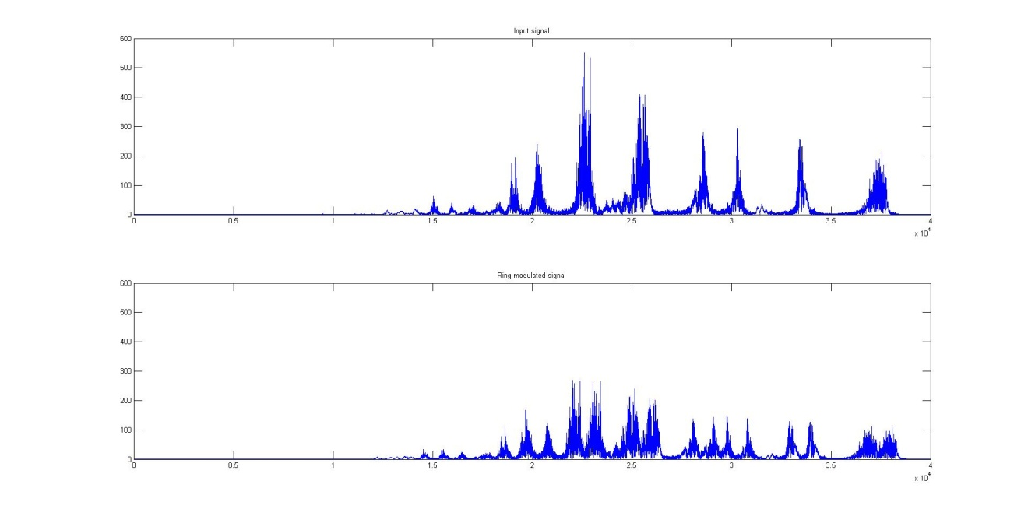

Figure - Ring Modulation

# 1.4 Vibrato, Flanging and Chorus

## 1.4.1 Varying fractional delay

A varying fractional delay in a system can be expressed as

$$y\left[n\right]=x[n-D\left[n\right]]$$

D[n] is a variable delay and time-dependent and will often be a non-integer value. Inferring the proper value as if it were in continuous time would ideally be done with an interpolation that sums infinite sinc functions, but since this is not feasible in code, we used a linear interpolation to infer the correct value for non-integer delays in time.

## 1.4.2 Implementing the effects

Vibrato can be achieved using a variable delay on a signal and can be used as a filter described by the transfer function:

$$H\left(z\right)=z^{-D[n]}$$

We used an oscillator with a fundamental frequency of 30Hz to filter an audio signal for a vibrato effect.

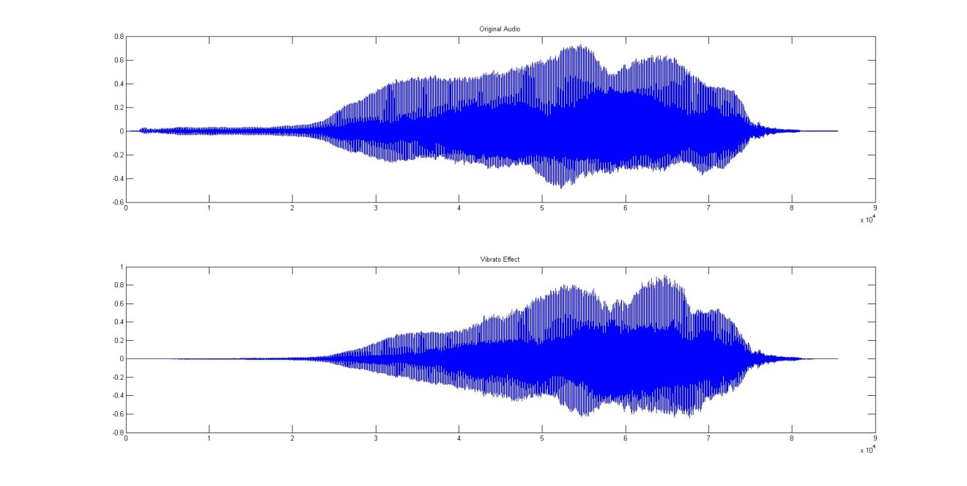

Figure – Vibrato Effect

Building further on this concept, a flanging effect can be achieved with a similar filter and a system described by the transfer function:

$$H\left(z\right)=z^{-D[n]}+1$$

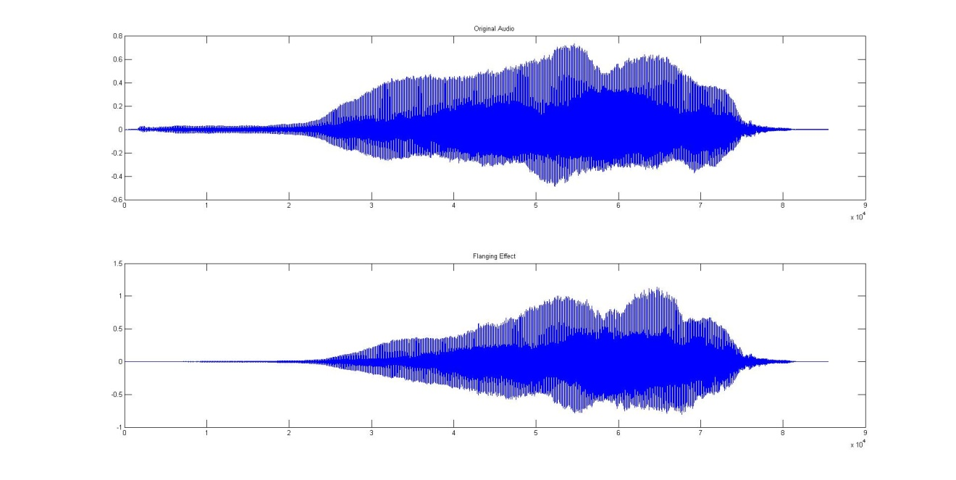

Figure – Flanging Effect

Building again on this concept, a series of different delays can be stacked in parallel to create a chorus effect

$$H\left(z\right)=z^{-D_{1}[n]}+z^{-D_{2}[n]}+…+z^{-D_{i}\left[n\right]}+1$$

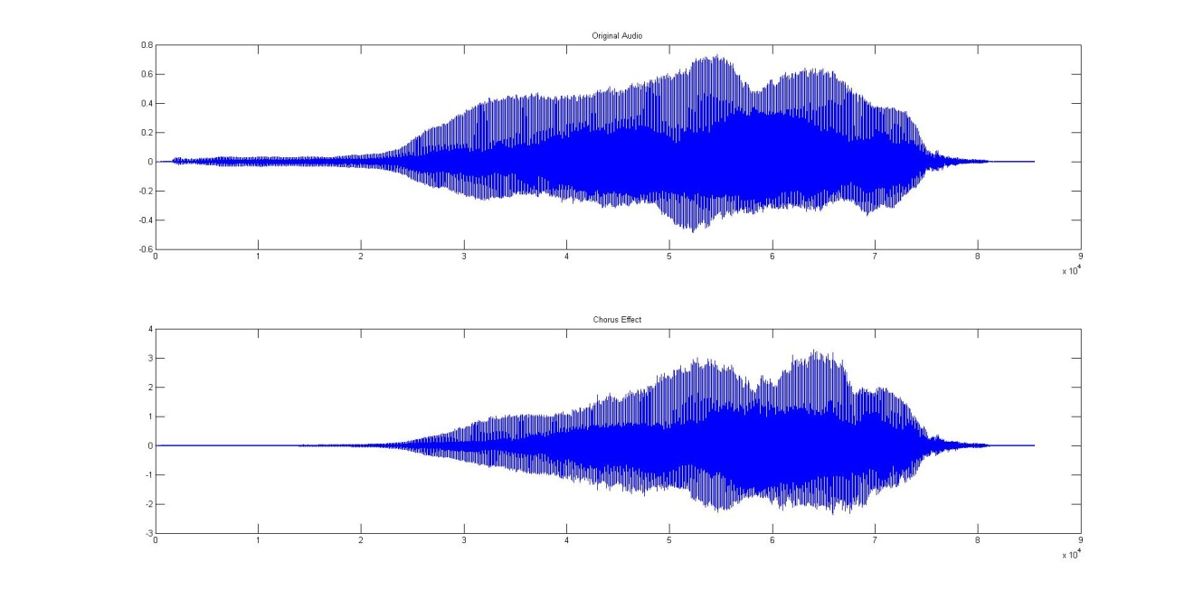

Figure – Chorus Effect